PROGRAMME SPECIFICATION

Awarding body/institution | Glyndŵr University
Teaching institution (if different from above) | Glyndŵr University
Details of accreditation by a professional, statutory or regulatory body (including link to relevant website) | N/A
What type of accreditation does this programme lead to? | N/A
Is accreditation in some way dependent on choices made by students? | N/A
Final award/s available  eg BSc/DipHe/CertHE | BSc (Hons) Sound Technology  BSc Sound Technology  Diploma of HE in Sound Technology  Certificate of HE in Audio Technology
Award title | BSc (Hons) Sound Technology
JACS 2 code | J930
UCAS code (to be completed by admissions) | HWP3
Relevant QAA subject benchmark statement/s | Communication, media, film and cultural studies (2008)
Other external and internal reference points used to inform the programme outcomes

Mode/s of study  (p/t, f/t, distance learning) | FT
Language of study | English
Date at which the programme specification was written or revised | July 25th 2010  Updated March 2013

Criteria for admission to the programme
The programme is subject to Glyndŵr University’s Principles, Policies, Regulations and Procedures for the Admission of Students to undergraduate programmes and will take account of University policy and guidelines for assessing accredited prior learning (APL) or accredited prior experiential learning (APEL).

Typical requirements:

General Entrance requirements have been set at the level of 240 UCAS points for BSc Hons degree level and 100 UCAS points for Foundation Degree through the following:

- A-Levels to be in a relevant subject such as Media/ Creative Technology/ Music Technology/ Science/ Maths/ Physics.
- National Diploma/Certificate in a relevant area such as Media/ Creative Technology/ Music Technology/ Science based subject
- It is normally expected for applicants to have achieved a pass at GCSE for Maths and English/Welsh.

All applicants are invited to tour the facilities to ensure that the course they are applying for meets their expectations. The programme content is discussed with applicants during their tour period.

Students will be accepted onto the programme in order of application and on meeting the required entry criteria.

Aims of the programme
- To produce graduate students with the knowledge, tools and competencies to enable a successful career within the broad and creative area of the Audio/Music Technology Industry.

- To enable the student to exploit and engage their understanding of new and emergent Audio/Music Technology media forms and their relation both to their industrial application, social context and to earlier forms.

- Provide a depth of critical understanding of key production processes and professional practices relevant to Audio/Music Technology, media, cultural and communicative industries, and of ways of conceptualising creativity and authorship.

- Enable the students to produce work showing capability in operational aspects of music technology, production technologies, systems, techniques and professional practices

- To engage the students with the methodologies of how, in creative industries, individuals or collaborative project-oriented teams are organised, enabling the student to have a competitive standing in the employment market
Distinctive features of the programme
The BSc (Hons) degrees offer the student the opportunity to develop audio technology knowledge which is specific to this modern, rapidly changing industry. The industry has evolved such that it depends on a highly technical base of operation and equipment. The degree offers the student the delivery of a modern curriculum aligned with current developments within the industry. The degree also offers the student the opportunity to develop emerging skills that will be adopted within the industry in the future.

Programme structures and requirements, levels, modules, credits and awards
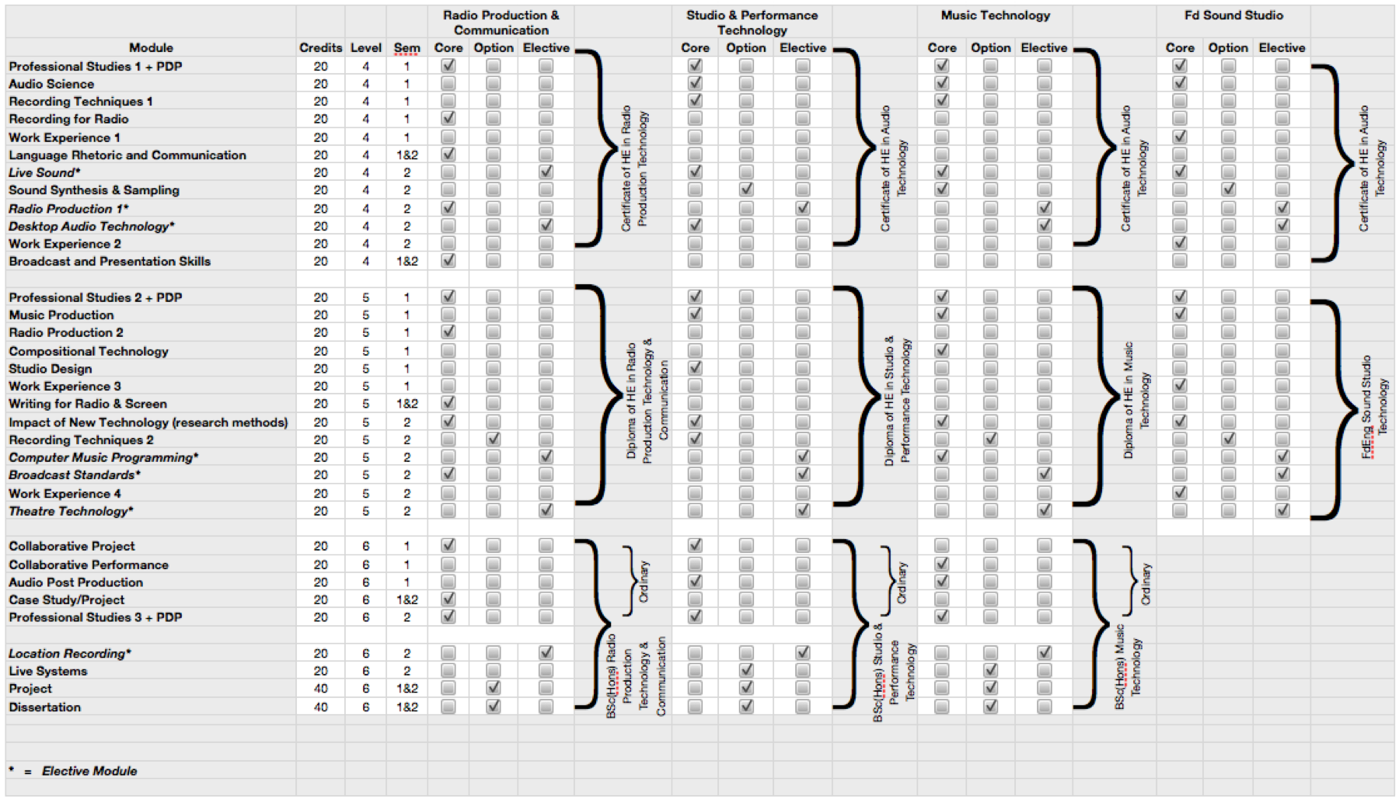

Intended learning outcomes of the programme

BSc (Hons) Sound Technology

A: Knowledge and understanding

A1: Theory: current concepts, principles and theories relevant to the Audio Technology industry
A2: Techniques: methods, tools and enabling technologies used in the area of creative Music Technology
A3: Applications: established applications of techniques developed within music technology
A4: Professional Issues: legal and ethical issues relating to the present and future use of technology developed within Audio Technology

Skills and other attributes

B: Intellectual/Cognitive Skills

B1: Evaluate and apply judgement to the techniques that relate to the Music and Audio industry
B2: Analyse problems and recognise opportunities to apply appropriate techniques to their solution
B3: Apply informed and reasoned arguments, descriptions and proposals that incorporate specialised Audio Technology knowledge
B4: Interpret the contents of articles and other sources, and form a judgement of their relative importance and relevance to an area of study

C: Practical Skills

C1: Make effective use of a range of techniques, support tools and development environments
C2: Produce work demonstrating audio technical expertise and manipulation of audio material
C3: Work as a member of a development team, contributing to the planning and execution of a shared design and implementation task
C4: Plan, undertake and report a self-directed individual programme of investigation, design and implementation

D: Key Skills

D1: Communication: Communicate effectively in written reports and oral presentations using appropriate terminology and technical language
D2: IT Skills: Retrieve information using search engines, browsers and catalogues; use appropriate IT facilities to prepare and present music/audio/visual projects and artefacts in various formats (documents, oral presentations)
D3: Numeracy: Use mathematical techniques in the processes of analysis and design
D4: Problem Solving: Analyse complex problems and design effective solutions
D5: Working with Others: Plan and manage team projects using available support tools; work effectively as part of a team
D6: Self Learning: Organise activity and manage time in a programme of self-directed study

BSc Sound Technology

On successful completion of the programme a graduate should demonstrate knowledge and skills as follows:

A: Knowledge and Understanding

A1: Theory : current and emerging concepts and principles relevant to the Audio Technology industry
A2: Techniques : current methods, tools and enabling technologies used in the area of creative Audio Technology
A3: Applications : established and potential applications of techniques developed within music technology
A4: Professional Issues : legal and ethical issues relating to the present and future use of technology developed within Audio Technology

B: Intellectual/Cognitive Skills

B2: Analyse problems and recognise opportunities to apply specialised techniques to their solution
B4: Interpret the contents of articles and other sources, and form an informed judgement of their relative importance and relevance to an area of study

C: Practical Skills

C1: Make effective use of a range of theories, techniques, support tools and development environments
C2: Produce work demonstrating Audio technical expertise and judicious manipulation of audio material
C3: Work as a member of a development team, contributing to the planning and execution of a shared design and implementation task

D: Key Skills

D1: Communication: Communicate effectively in written reports and oral presentations using appropriate terminology and technical language
D4: Problem Solving: Analyse problems and design effective solutions
D5: Working with Others: Plan and manage team projects using available support tools; work effectively as part of a team
D6: Self Learning: Organise activity and manage time in a programme of self-directed study

Diploma of HE in Sound Technology

On successful completion of the programme a graduate should demonstrate knowledge and skills as follows:

A: Knowledge and Understanding

A1: Theory: current concepts, principles and theories relevant to the Audio Technology industry
A2: Techniques: methods, tools and enabling technologies used in the area of creative Music Technology
A3: Applications: established applications of techniques developed within music technology
A4: Professional Issues: legal and ethical issues relating to the present and future use of technology developed within Audio Technology

B: Intellectual/Cognitive Skills

B1: Evaluate and apply judgement to the techniques that relate to the Music and Audio industry
B2: Analyse problems and recognise opportunities to apply appropriate techniques to their solution
B3: Apply informed and reasoned arguments, descriptions and proposals that incorporate specialised Audio Technology knowledge
B4: Interpret the contents of articles and other sources, and form a judgement of their relative importance and relevance to an area of study

C: Practical Skills

C1: Make effective use of a range of techniques, support tools and development environments
C2: Produce work demonstrating audio technical expertise and manipulation of audio material
C3: Work as a member of a development team, contributing to the planning and execution of a shared design and implementation task
C4: Plan, undertake and report a self-directed individual programme of investigation, design and implementation

D: Key Skills

D1: Communication: Communicate effectively in written reports and oral presentations using appropriate terminology and technical language
D2: IT Skills: Retrieve information using search engines, browsers and catalogues; use appropriate IT facilities to prepare and present Music/audio/visual projects.
D3: Numeracy: Use mathematical techniques in the process of design
D4: Problem Solving: Analyse practical problems and design effective solutions
D5: Working with Others: Plan team projects using available support tools; work effectively as part of a team
D6: Self Learning: Organise activity and manage time in a programme of self-directed study

Certificate of HE in Audio Technology

On successful completion of the programme a graduate should demonstrate knowledge and skills as follows:

A: Knowledge and Understanding

A1: Theory: current concepts, principles and theories relevant to the Music Technology industry
A2: Techniques: methods, tools and enabling technologies used in the area of creative Audio Technology
A3: Applications: applications of techniques developed within music technology
A4: Professional Issues: An understanding of legal and ethical issues relating to the use of technology developed within Audio Technology

B: Intellectual/Cognitive Skills

B1: Understanding of the techniques that relate to the Music and Audio industry
B2: Be aware of problems and recognise opportunities to apply solutions
B3: Construct arguments that incorporate specialised Audio Technology knowledge
B4: Include the contents of articles and other sources, and display understanding of their relative importance and relevance to an area of study

C: Practical Skills

C1: Utilise a range of techniques, support tools and development environments
C2: Produce work demonstrating music-technical competence and appropriate manipulation of audio material
C3: Work as a member of a development team, contributing to the execution of a shared design and implementation task

D: Key Skills

D1: Communication: Communicate clearly in written reports and oral presentations using appropriate language.
D2: IT Skills: Retrieve information using search engines, browsers and catalogues; use appropriate IT facilities to prepare portfolio of work.
D3: Numeracy: Develop mathematical skills in the processes of investigation and design.
D4: Problem Solving: Analyse practical problems and offer potential solutions.
D5: Working with Others: engage with team projects using available support tools; explore working as part of a team.
D6: Self Learning: Organise activity and manage time in a programme of self-directed study.

CURRICULUM MATRIX demonstrating how the overall programme outcomes are achieved and where skills are developed and assessed within individual modules.
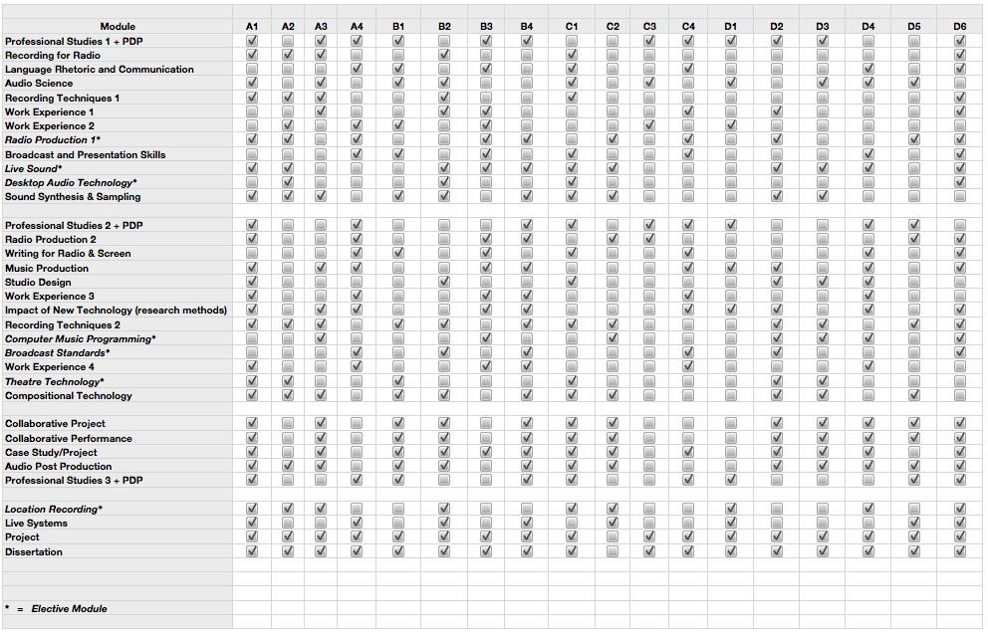
Learning and teaching strategy used to enable outcomes to be achieved and demonstrated
To be able to deliver courses relevant to the Audio/Radio Technology Industry, the mode of delivery will continue to be flexible in order to be accessible. Presenting an infrastructure that is similar to that found within the industry will be a key opportunity for the development of flexible learning that matches the expectations of the new convergent digital technology industry.

Considerable expertise has been gained in the subject area of Audio/Radio Technology, the staff of which have been leading initiatives for degrees in the creative industries. This has proved that the implementation of campus-based work experience can successfully deliver the expected learning outcomes for the industry and offers continued development in this area due to the imminent construction of the new Creative Industries centre.

Students are given the opportunity to engage with extra curricular opportunities, the concept being to develop a professional portfolio of production pieces and a record of engagement with the industry. There are various methods for achieving this; The Total Audio Society formed by the students gives an opportunity to apply skills that have been learnt in modules such as Recording Techniques. Live Sound and Audio Science, the society operates all live music within the Students Guild.

There is also the opportunity to engage with CalonFM a community radio station who reside within the Campus. The station gives a valuable platform for interaction with a professional broadcasting station.

Access to the learning and teaching resources outside of the traditional University hours is an established protocol for the Audio area. The Wall studio operates on a 24hr basis and this has proved beneficial for students and staff.

The offering of an industry-style model gives the student the experience and realism of the area in which they intend to operate. The industry by nature is entrepreneurial and operates whenever there is the requirement for production work to be completed. The use of the radio station also gives the student the access to a broadcast medium to showcase the work outcomes. The development of the suite of facilities as a teaching and learning vehicle, integrated with professional applications is such that the team decided that examinations were not a suitable method for assessing the academic and professional skills gained by the students as they progress though the levels. It was decided that importance would be placed on timeliness of production, professional attitude, ability to articulate and pass on clear information within team settings. This manifests itself as the skills required to operate in a changing creative area. This work will be developed further now the member of staff seconded to the Liverpool Capital of Culture project has returned and can use the knowledge gained in managing interaction between participants of that project to enhance the Glyndŵr University development of creative projects.

Welsh Medium
Whilst the programme will be delivered in English, students are entitled to submit assessments through the medium of Welsh if they wish.

Assessment strategy used to enable outcomes to be achieved and demonstrated
Assessment methods across all modules relate directly to learning outcomes through the emphasis on assessment of the audio output, in terms of:

- The quality of the final audio product, in terms of creativity, originality, technical proficiency, use of technology and language;
- Accompanying evidence of creative and technical processes leading to the realisation of the final product (drafts, annotations, evidence from Process Journals, etc);
- Evidence that audience, reader or client considerations have been addressed, and that it is fit for the purpose for which it is intended;
- Evidence of self-critical and positive reflection at various stages throughout the programme.

The team apply a range of assessment approaches, to reflect the nature of the creative industry. By bringing in some self-assessment, peer-assessment and group assessment the student will develop self reflection and moderation of thought, which are both skills required for this discipline. This can be achieved both within the traditional assessment formats such as essays and reports, but is more often introduced beyond these traditional formats, including the assessment of:

presentations;
posters;
performances;
portfolios of evidence;
reflective logs;
artifacts such as DVD’s; Webcasts; Video Production, and so on;

Assessment is not only intended to validate the student knowledge at an appropriate level to their level of study, but is also designed to give incremental support. Differing styles of assessment are time-released through the VLE (virtual learning environment). Therefore students have access to a resource that issues the information at the correct time to support relevant curriculum areas.

Formative assessment helps to develop student style and is found to be supportive and developmental. It is delivered by feedback through the tutorial process; the student will present, typically, an outline summary of intended submission. By discussion with the tutor, suitable guidance is intended to be developmental and not merely incremental. The enabling process gives guidance for summative assessment, which provides a measure of student performance or level against the defined outcomes.

Assessment formats for all modules are based on exercises, journals and logs in addition to the written pieces of work submitted for assessment. Submission of portfolios and all assessed work is timed to avoid the bunching of assessment.

Feedback with respect to formally submitted work will normally be within 15 working days from the formal submission date.

Assessment regulations that apply to the programme
The University’s academic regulations for Bachelor Degrees, Diplomas, Certificates and Foundation Degrees apply to this programme.

Programme Management
Academic Head of Department: Dr Stuart Cunningham
Programme Leader: Mike Wright
Module Leaders: Colin Heron
John Reynolds
Rich Smith
Sessional Lecturers: Graeme Park
Darren Hughes.

The course will be informed by data such as the National Student Survey (when the final year is reached). Each programme within the Department nominates student representatives and the VLE is used to interact with the student cohort and to perform part of the function of the Staff Student Consultative Committee; routine physical SSCC meetings also occur each semester, chaired by an external member of staff from outside the area. Students are also asked to undertake module evaluation and programme evaluation via the VLE and this feedback is also used to inform the annual monitoring report: students receive responses via the VLE.

The informed comments from external examiners aid in the development of the degree route. Also members of the team external examine similar courses. This enables comparison and benchmarking of standards to be carried out.

All staff members within Communications Technology are members of University committees; this is from Departmental to Institutional level. This interaction ensures that information and processes are kept current.

Particular support for learning
Students studying within the Department have a range of support mechanisms available to them. These are explained and offered from before the student joins the course. The process starts from the first contact or expression of interest.

The induction process introduces the student to the range of support offered by the programme team and Glyndŵr University. Sessions are offered with regard to finance, additional learning needs, time management, and learning enhancement, including numeric or language skills.

The propgramme team offers support mechanisms through the VLE as well as allocating each student a personal tutor, someone they can turn to ask for direction. If any issues develop that cannot be facilitated within the programme team, then the student is advised at induction that they can have recourse to staff outside of the Department.

Students are invited to be represented at programme and institutional level so that they have the opportunity to have their views represented and responded to. The VLE forum also offers this function, with student response being timely.

The students regard this now as the norm and they use the interaction available to them to enhance their course of study. Many attend extra-curricular events that are organised generally on a weekly basis with many of the Department staff attending events that run until late in the night. This extra function develops the students socially and technically as they relish the time available to develop the skills to operate in a live environment.
Equality and Diversity
Glyndŵr University is committed to the principle of lifelong learning and to widening access particularly to those groups who have not traditionally accessed higher education. To this end applications from prospective students who do not meet the formal educational qualifications for entry will be considered on an individual basis.

Such applicants will be expected to demonstrate through interview that they have the potential to succeed on the course. The Personal Development delivered in Year 1 will be used as a means of ensuring that students who enter through this route are provided with the appropriate skills development opportunities and support from the Team.

